Class / object diagram - examples





**Travel management in university**.

Employees of companies and universities may travel for business. In this case expenses for the travel are paid by the company and accidents are covered by the company’s insurance. However a specific procedure must be followed.

First the employee has to ask authorization to do the travel. If granted, the employee performs the travel and pays part or all of the expenses. Finally the employee asks for reimbursement. The company checks the expenses and reimburses all or part of them. Expenses are then written in the balance sheet of the company. Both for checks and for accounting each expense must be documented (invoice, note, ticket) and stored for 5 years. A number of rules defines the type of expenses that are reimbursed and the reimbursement level (for instance no trips in business class, or trips in any class but with a reimbursement ceiling).

In a certain university the AS IS situation is as follows. The university is organized in 11 departments. Each department has an administrative employee in charge of the process. The employee who needs to travel fills in a paper form (in fact an excel sheet with a defined template, that is later printed), attaches to it paper documentation to justify the travel (request from a superior in hierarchy or invitation from other university or else) signs and hands the paper folder to the administrative employee in the department. The administrative employee performs an initial check (all needed information and documents are available) and if positive submits all to the director of department. The director signs the authorization (or not if some rule is violated). The paper folder is sent back to the employee – this closes the authorization process.

After the travel the employee fills another paper form (again an excel sheet with a defined template) with the list of expenses done during the travel (hotels, trains/buses, food etc). The employee signs the form (declaring under his responsibility that the expenses are real). For each expense a (paper) evidence must be attached. All is added to the paper folder. The paper folder is handed again to the administrative employee in the department. The administrative employee checks the expenses, approves them or not (according to company rules), computes the amount to be reimbursed and performs the reimbursement. He also has to record the expenses in the accounting system. Also the reimbursement is done as a bank transfer to the employee, via the accounting system. Finally the employee stores the folder in a specific cabinet where it is kept for at least 5 years.

The TO BE situation is as follows. A web portal is set up with a web application to handle the process. The employee fills in the travel request with the same information but of course digital (documents are attached as files to the request), signs it electronically. Completeness checks are done automatically. Higher level checks are performed by an administrative employee. However, a new central office for the whole university is set up for these tasks (instead of 11 administrative employees, one per department). If all checks are passed the travel request is approved, and the employee is notified by the web portal.

Similarly, after the travel the employee fills the second form on the web portal, attaches for each expense evidence (in form of scan of documents, files etc), signs digitally. Again the central office checks, possibly approves, reimburses. The new application is linked directly with the accounting system to record all expenses, and to the banking system for the bank transfer to the employee. By law paper evidence of expenses has still to be stored for 5 years. So in the end the employee collects (or prints) evidence and sends it by internal mail to the central office, that stores it for 5 years.

Functional model - data



Bpmn version 1

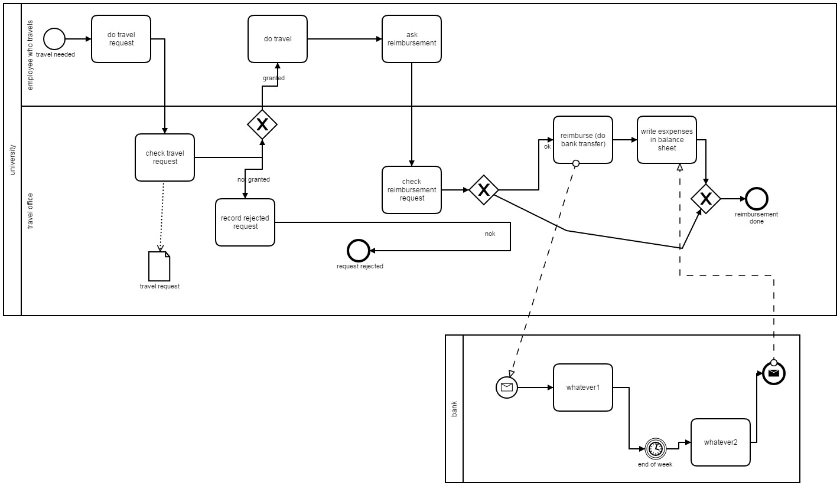

Version 2

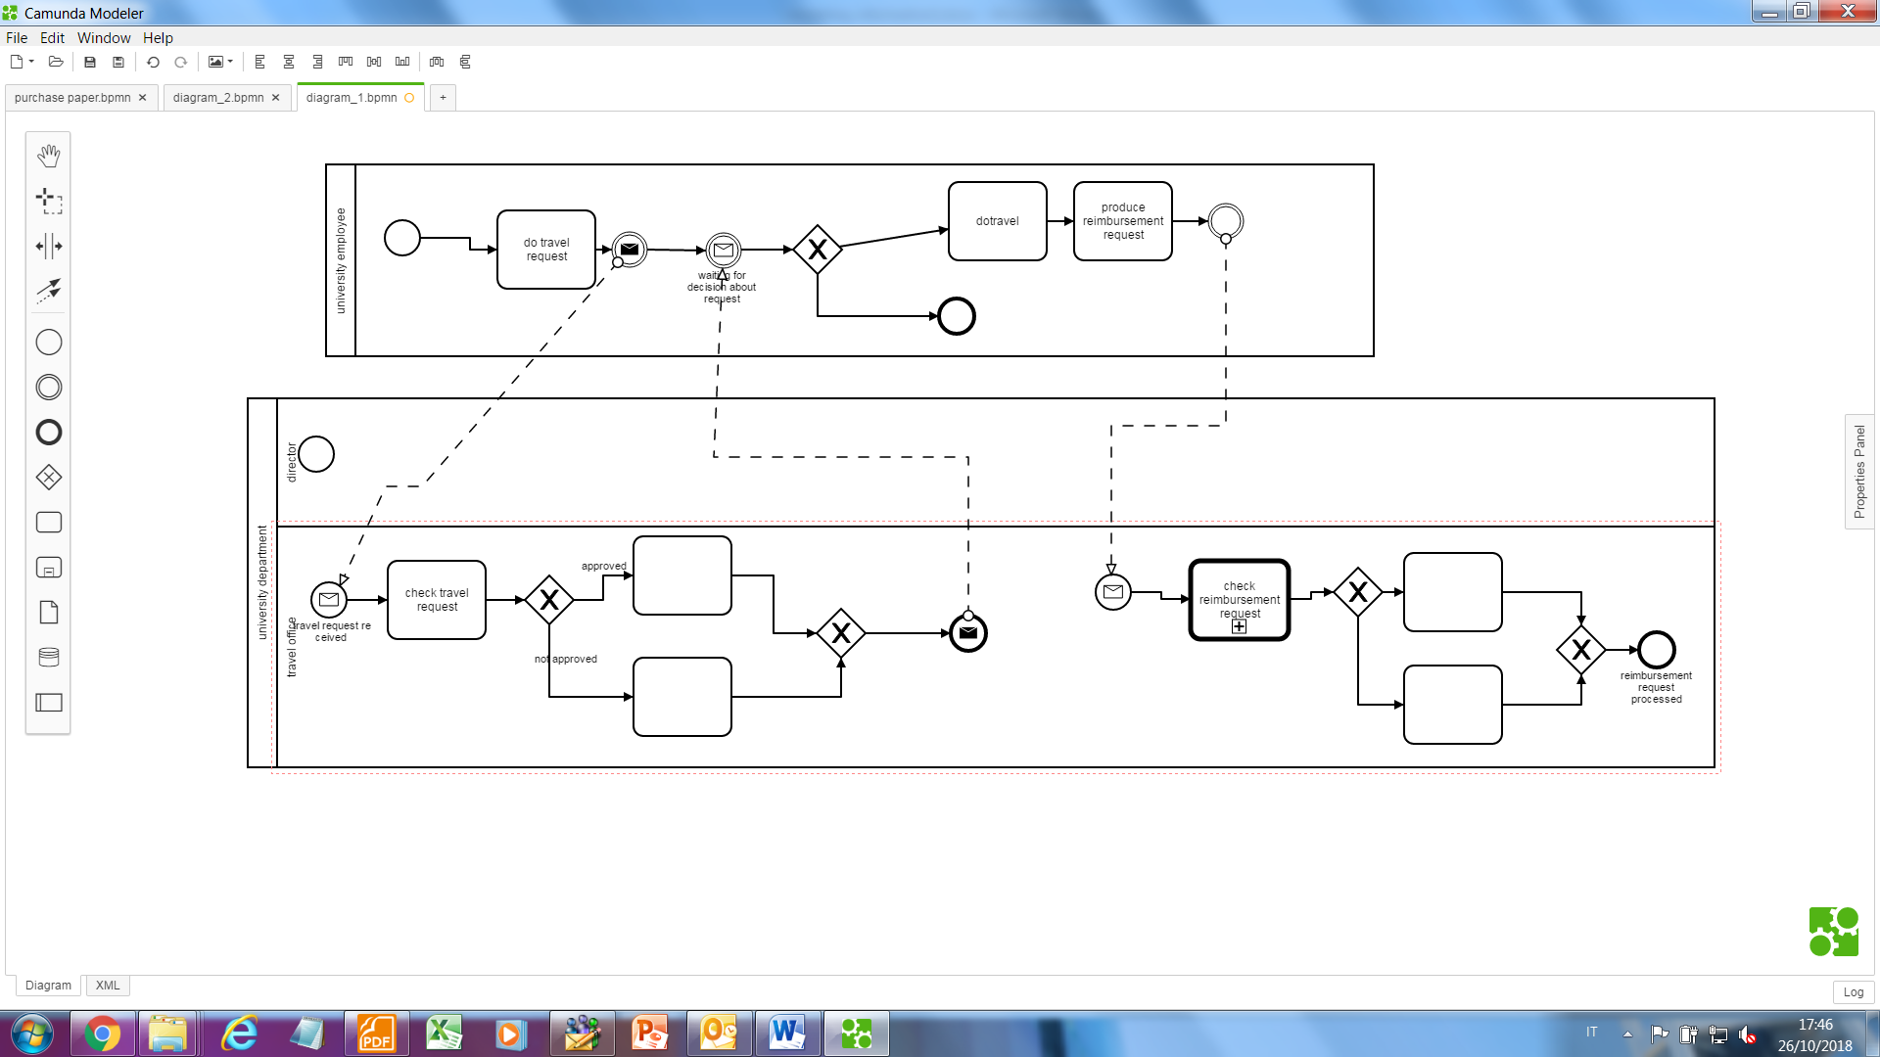

Define conceptual diagram for university.

In a university there are different classrooms, offices and departments. A department has a name and it contains many offices. A person working at the university has a unique ID and can be a professor or an employee.

* A professor can be a full, associate or assistant professor and he/she is enrolled in one department.
* Offices and classrooms have a number ID, and a classroom has a number of seats.
* Every Employee works in an office
* Employees (not professors) work either in a department or in a central office
* An employee enters and exits a classroom
* Every employee has an account and password to access online services



Define conceptual diagram for flight management

An airline operates flights. Each airline has an ID.

Each flight has a code a departure airport and an arrival airport: an airport has a unique identifier.

Each flight has a pilot and a co-pilot, and it uses an aircraft of a certain type; a flight has also a departure time and an arrival time.

An airline owns a set of aircrafts of different types.

An aircraft can be in a working state or it can be under repair, and in a particular moment an aircraft can be landed or airborne.

A company has a set of pilots: each pilot has an experience level: 1 is minimum, 3 is maximum.

A type of aircraft may need a particular number of pilots, with a different role (Ex. captain, co-pilot, navigator): there must be at least one captain and one co-pilot, and a captain must have a level 3.

A pilot can play different roles (ex pilot vs co-pilot) in function of the flight.

A flight, in function of its range (distance) requires a certain type of aircraft.

|  |  |  |
| --- | --- | --- |
| Range | Possible types |  |
| 0 2000 km | 737, A319, A320 |  |
| 2000 10000km |  |  |
| >= 10000km | A380, B747 |  |

|  |  |  |  |
| --- | --- | --- | --- |
| Type of aircraft | Captain | Copilot | Navigator |
| A319 | Experience level 3 | Experience level 2 | NO |
| B747 | Experience level 4 | Experience level 2 | Experience level 2 |



Second version. In previous model Pilot can be EITHER a captain OR a Copilot OR a navigator. In this version captain etc become roles, using three different associations



As in previous model some constraints are probably more understandable as tables than as business rules

|  |  |  |
| --- | --- | --- |
| Range | Possible types |  |
| 0 2000 km | 737, A319, A320 |  |
| 2000 10000km |  |  |
| >= 10000km | A380, B747 |  |

|  |  |  |  |
| --- | --- | --- | --- |
| Type of aircraft | Captain | Copilot | Navigator |
| A319 | Experience level 3 | Experience level 2 | NO |
| B747 | Experience level 4 | Experience level 2 | Experience level 2 |